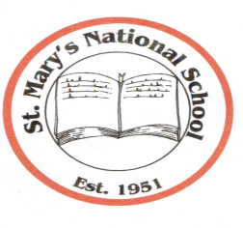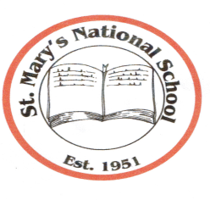
St. Mary’s National School
Parnell Avenue ♦ Enniscorthy ♦ County Wexford
Acting Principal: Mrs. Gillian Wilson,
Tel: 053 9235728 ♦ Email: principal1stmarys@gmail.com
Web Site: www.stmarysnsenniscorthy.ie
Chairperson: Mr R. Syme Patron: Bishop Michael Burrows

Third Class – Book List
Books and sundries you need to purchase for your child for the school year commencing 30th August 2017.
- BéalBeo 4 (Edco)
- Mathemagic 3rd class (CJ Fallon)
- New Wave Mental Maths 3 (Prim Ed.)
- Table Book – Time for Tables (Educational Company) – should have
- Word Wise 3 (CJ Fallon)
- Oxford School Dictionary (Educational Company)- should have
- Just Handwriting – 4th class (educate.ie)

- 6 x 88 page copies
- 3 x 88 page Maths copies
- 2 x Nature Study copies (alternative ruled and blank)
- 1 Handwriting copy (Learn to write B4)
- Pencils, colouring pencils, sharpener, rubber and 30cm ruler
- Pritt Stick (to leave in school)
- Scissors (to leave in school)
- Highlighter (to leave in school)
- Packet of markers (to leave in school)
Please label all your child’s belongings clearly before bringing into school.
All other books required are available under the Book Rental Scheme.

Book Rental/Folders/Homework Journal/Photocopying/Art Materials/Licences for Digital Resources etc. €50 (due in September 2017)

