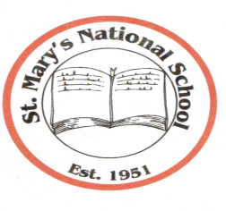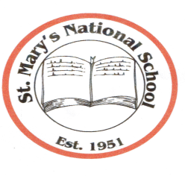
St. Mary’s National School
Parnell Avenue ♦ Enniscorthy ♦ County Wexford
Acting Principal: Mrs. Gillian Wilson,
Tel: 053 9235728 ♦ Email: principal1stmarys@gmail.com
Web Site: www.stmarysnsenniscorthy.ie
Chairperson: Mr R. Syme Patron: Bishop Michael Burrows

Sixth Class – Book List
Books and sundries you need to purchase for your child for the school year commencing 30th August 2017.

- BéalBeo 6 (Edco)
- Mathemagic 6th class (CJ Fallon)
- New Wave Mental Maths 6 (Prim.Ed.)
- Table Book – Times for Tables (Educational Company) – should have
- Word Wise 6 (CJ Fallon)
- Small World – History
- Small World – Geography and Science
- Oxford School Dictionary (Educational Company) – should have
- Just Handwriting – 6th class (educate.ie)
- Mathematical Set and Calculator
- Ring Binder Folder
- 6 x 88 page copies
- 2 x 88 page Maths copies
- 2 x A4/A5 Hardback copies
- Pencils, colouring pencils, sharpener, rubber and 30cm ruler.
- Pritt Stick (to leave in school)
- Scissors (to leave in school)

Please label all your child’s belongings clearly before bringing into school.
All other books required are available under the Book Rental Scheme.

Book Rental/Folders/Homework Journal/Photocopying/Art Materials/Licences for Digital Resources etc. €50 (due in September 2017)

