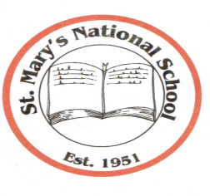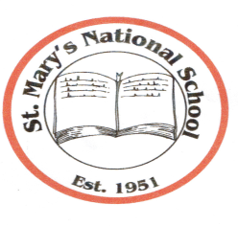
St. Mary’s National School
Parnell Avenue ♦ Enniscorthy ♦ County Wexford
Acting Principal: Mrs. Gillian Wilson,
Tel: 053 9235728 ♦ Email: principal1stmarys@gmail.com
Web Site: www.stmarysnsenniscorthy.ie
Chairperson: Mr R. Syme Patron: Bishop Michael Burrows

HEALTHY EATING GUIDELINES
St Mary’s N.S. will try to develop and encourage healthy eating among all children.
Parents will be encouraged to provide their child / children with a healthy, nutritional lunch – a filled roll or sandwich, fruit, yoghurt, a drink (NO FIZZY DRINKS ALLOWED) ( NO LOLLIPOPS ALLOWED) ( NO CHEWING GUM ALLOWED)
Children may bring a small treat on Fridays only.
No child will be refused a drink anytime during the school day.
Classwork will stop 10 minutes before break times to give children ample time to eat their lunch before they go outside.
As part of the Social, Persona l and Health Education programme, St Mary’s NS will encourage the children to become more aware of the need for healthy food in their lunch box and as a follow on
- To foster in children an appreciation of the importance of good nutrition for growing, developing and staying healthy
- To heighten an awareness and understanding in children of the importance of a balanced diet
- A positive attitude to food will be encouraged. Children should enjoy their food - all foods have a place in a balanced diet.
- To encourage children to make wise and sensible choices about food and nutrition and adopting a positive healthy eating habit for life
- The importance of physical activity will be promoted and encouraged in children
- Children’s work on healthy eating will be displayed along school corridors and in classrooms
The above guidelines are as a result of involving pupils, teaching staff and parent focus groups and listening to their suggestions and ideas.
Some suggestions for healthy nutritious lunch boxes from the pupils of St Mary’s NS are:
- Brown bread or rolls
- Rice
- Pasta
- Scones
- Crackers
- Lean meat – chicken /turkey
- Cheese
- Yoghurt
- Fruit – apples, bananas, peaches, plums, mandarin oranges
- Vegetables – tomatoes, cucumbers, sweetcorn
- Drinks – milk, water, diluted sugar free fruit drink
These guidelines were approved by the Board of Management at a meeting on Monday 27th February 2017.

