Suggested Work for 5th & 6th Class Week Beginning April 27th
Maths - The topics this week are Directed Numbers and The Circle.
- Numbers can be positive (1, 2, 3, 4, etc. ) or negative (-1, -2, -3, -4, etc.) We usually call these minus numbers. Using a number line is very helpful when beginning to look at numbers in two directions.
- The Circle is a short, but a bit complicated chapter – the book doesn’t explain it very well and the way you learn about the circle changes in secondary school anyway, so don’t worry about how to find the circumference or area of a circle. The most important this is just make sure you understand these terms – centre point, radius, diameter, circumference, arc and sector, and that you know the diameter is twice the length of the radius (d=2r), and the radius is half the diameter.
English – Activities are listed below. You can send videos, voice recordings, photos of written work, I don’t mind how – but I would like to see something to show what you’ve done.
Irish – Cula4 & RTE school hub.
Bileog 17 – I’ve included a worksheet below with sentences for you to translate. 6th class should manage all of these. You can write them all, or do some of them orally (speaking) I suggest you write at least 5 of them each day. I’ll send the answers afterwards so you can see if or where you went wrong.
I’m not sure how you’re finding the Irish at home, or even what you’re watching on TV? It’s a good idea to practice reading some Irish anyway. Look at and read pages 108 & A on p. 109, and the Comhrá on p.110 in Abair Liom and see how much you understand. Then try listening to the clips I’ve attached in the powerpoint.
Spellings: Spellings for 5th & 6th Class are at the end of this document. Learn and practice these each night as you normally would for homework.
SESE: The topics for History, Geography and Science are continuing on from last week. Either keep working on both if you started them last week, or move one to the other if you only did one last week.
History – Revolutions. Read Unit 11 staring on p60 and do the activities at the end of the chapter. Or Do a mini project about a person who led a revolution (these can be peaceful or involve fighting). Write a report about the revolutionist, including a bit about their life, how things were before and the main changes they brought about, as well as what they are mainly remembered for. You’ll find some ideas for people who led revolutions here https://www.biographyonline.net/people/famous/revolutionaries.html
Geography / Science: Animals Read Unit 11 about animals starting on p62 (p60 & 61 might be interesting too). Then do the activities at the end of the chapter, or research an animal, or group of animals that really interests you. Write a report about that animal mentioning facts about their lifespan, diet, habitat, appearance, body, and behaviour.
Art: Creative Booklet – I’ve included the next two tasks below – you can design your own version of this worksheet, or print and complete the pages attached. If you tried any activities from the Art Farm page – I’d love to see your creations.
1960s Mini Project: Find out about what music, fashion and movies were like in the 1960s. Here are some ideas for this kind of project, but feel free to look into areas that interest you:
- Design a sixties style outfit
- Research some music artists and bands
- Listen to music from the 60s, learn some songs
- Create a dance in the style of this decade
- Learn about famous people from this decade
- Make a timeline of big events which happened in the 1960s
PE: Keep exercising – at least 30 minutes a day, and more if you can. Look at the Dance Moves in the 1960s PowerPoint - have some fun listening to 60s music and trying out some dance moves from the sixties.
If you’re feeling stressed, angry, frustrated or even a bit fed up – I challenge you to try some yoga. This is a quite a short video to get you started (10 mins) https://www.youtube.com/watch?v=Td6zFtZPkJ4. It might be hard not to get distracted at first but it’s really good for concentration , focus and balance once you get going.

Subject | Monday 20th | Tuesday 21st | Wednesday 22nd | Thursday 23rd | Friday 24th
Maths | Mental Maths Wk 28 Monday  Mathemagic  5th Class: Ch 29 Directed Numbers p. 127 Q2 – Write the time and temperature for each part.  p.128 Q 1 - 6  6th Class: Ch 29 Directed Numbers p. 125 Q 1, 3 & 4 | Mental Maths Wk 28 Tuesday  Mathemagic  5th p. 129 Q 1 & 2  6th p. 126 Q 1 & 3 | Mental Maths Wk 28 Wednesday  Mathemagic  5th p. 130  6th p. 127 Q 1 – 3 (Pogs are positives and Nogs are negative) | Mental Maths Wk 28 Thursday  Mathemagic  5th p. 131 The Circle -Read the information in the two green boxes to learn about the arc, centre point, sector radius, circumference, and diameter.  p. 132 Q3, 4 & 5  6th p. 128 Q 2 - 6 | Mental Maths Wk 28 Friday Review  Mathemagic  5th If you think you’re able, try what you can on p.133 & 144, if not do Q1 & 2 on p. 132  6th p. 129 Read through the green box & speech bubble. Try Q1, 2 & 3 on p.130 if you can.
English | Read for at least 20 – 30 minutes  P66 Spelling Rules & 67 Adjective Activity | Read for at least 20 – 30 minutes  AWW 6 – p. 72 A: Read the Review and answer the questions | Read for at least 20 – 30 minutes  Write a poem or story for the title ‘When life is normal again’ | Read for at least 20 – 30 minutes  AWW 6 p. 70 Adverbs | Spelling Test  Write a summary of what has happened so far in the book you are reading – remember to include the title of the book.
Irish  An Aimsir – The Weather | Cúla 4 / RTE School Hub  Bileog 17 A | Cúla 4 / RTE School Hub  Bileog 17 B | Cúla 4 / RTE School Hub  Bileog 17 C | Cúla 4 / RTE School Hub  Bileog 17 D | Cúla 4 / RTE School Hub

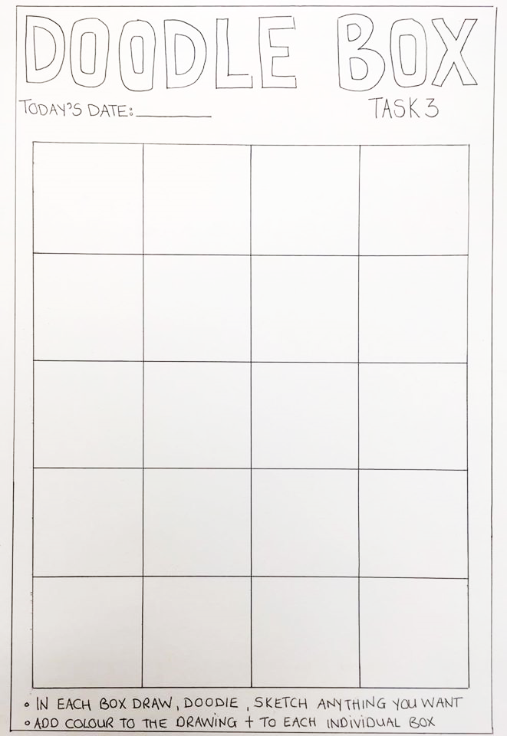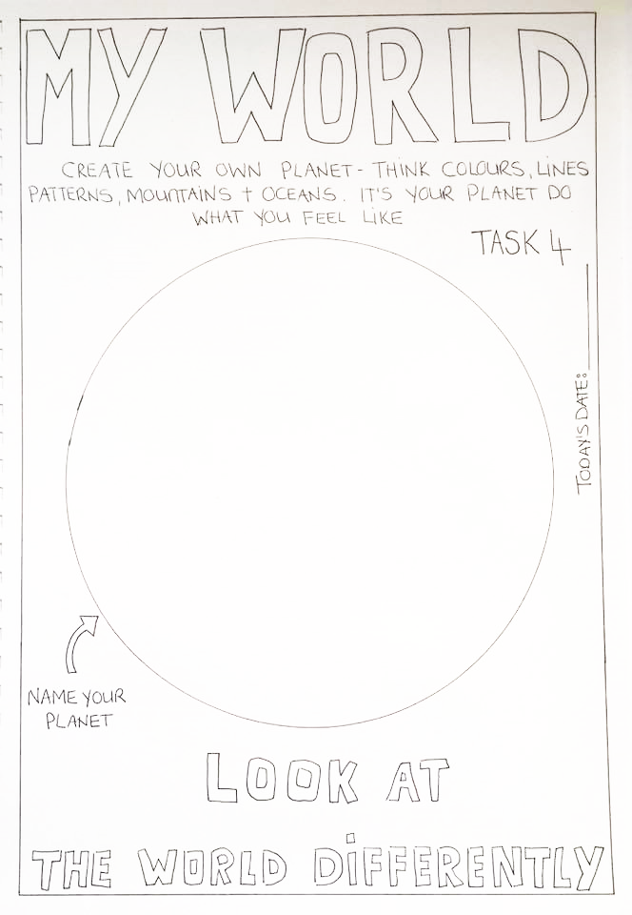
Monday
Tuesday
Wednesday
Thursday
Week 22 – 5th Class
‘ue’ and ‘re’

Remember: ‘ue’ makes the ‘long u sound’
In ‘re’ the e makes a ‘short e sound’
(This must be done Monday to Thursday for homework.)
Look, say, cover, write, check.
1 | argue
2 | rescue
3 | avenue
4 | barbecue
5 | statue
6 | continue
7 | undervalue
8 | Tuesday
9 | religion
10 | recommend
11 | represent
12 | relative
13 | recipe
14 | recognise
15 | revenge
16 | resident

Monday
Tuesday
Wednesday
Thursday
Week 22 – 6th Class
‘ue’ and ‘re’

Remember: ‘ue’ makes the ‘long u sound’
In ‘re’ the e makes a ‘short e sound’
(This must be done Monday to Thursday for homework.)
Look, say, cover, write, check.
1 | argue
2 | rescue
3 | avenue
4 | barbecue
5 | truehearted
6 | statue
7 | continue
8 | undervalue
9 | Tuesday
10 | discontinue
11 | religion
12 | recommend
13 | represent
14 | relative
15 | redundant
16 | recipe
17 | recognise
18 | revenge
19 | resident
20 | responsible

Obair Bhaile Gaeilge Bileog 17
ghlanamar we cleaned bhriseamar we broke
dhúnamar we closed ritheamar we ran
scríobhamar we wrote d’itheamar we ate
d’ólamar we drank thiteamar we fell
chasamar we turned d’éisteamar (le) we listened (to)
d’fhéachamar (ar) we looked (at) d’fhilleamar we returned
chanamar we sang léimeamar we jumped
stopamar we stopped léamar we read
chaitheamar we threw ghearramar we cut

1. We looked at television. 6. We broke the window.
2. We wrote a story. 7. We cleaned the kitchen.
3. We listened to Seán. 8. We turned around and we ran home.
4. We sang a song. 9. We jumped up and we fell down.
5. We drank milk and we cut the cake. 10. We returned to the shop.
A.

B.
cheannaíomar we bought dhúisíomar we woke up
thosaíomar we started d’éiríomar we got up
d’osclaíomar we opened bhailíomar we collected
d’ardaíomar we lifted níomar we washed
chuardaíomar we searched tharraingíomar we drew

1, We woke up at eight o’clock. 6. We lifted the table.
2. We got up at nine o’clock. 7. We washed the floor.
3. We opened the door. 8. We started laughing.
4. We bought chocolate and sweets. 9. We collected money.
5. We searched the house. 10. We drew a picture.

C
ansin then
- We jumped up and turned around. 6. We ran to the shop and bought crisps.
- We woke up at seven o’clock and then we got up.
- We sang a song and then we 7. We collected money and we bought sweets.
started dancing. 8. We opened the window and looked out.
4. We cleaned the table. 9. We drank tea and we ate cake.
5. We lifted the cupboard. 10. We listened to Liam.

D.
- We searched the house, but the money was not there.
- We started talking and laughing in the classroom.
- We tidied the kitchen and we cleaned the floor.
- We woke up at eight o’clock and we got up at nine.
- We drank coke and we ate sweets.
- We ran to the shop and then we returned home.
- We turned around and looked at Róisín.
- We opened the window and we looked out.
- We washed the trousers and the socks.
- We stopped talking and we started to work.

