Suggested Work for 5th & 6th Class Week Beginning May 11th
Maths - The topic this week is Weight. There are some practical activities you can try at home. When working with grams and kg in your copy, it’s a good idea to use one number per box to keep it in line and avoid getting mixed up.
English – This week I’m asking you to write a story which you can spread over a few days if you prefer. It should be at least 2 – 3 copy pages long. I’ve included some templates below which you can use to help you.
Irish – As well as the Bileog included below, do Irish as part of Cúla 4, RTE School Hub or Duo Lingo each day.
Bileog 19 6th class should manage all of these. You can write them all, or do some of them orally (speaking) I suggest you write at least 5 of them each day. I’ll send the answers afterwards so you can see if or where you went wrong.
I’m also including a few activities from Abair Liom each day, try these as best you can. Send pictures to me if you’d like me to correct it.
Spellings: Spellings for 5th & 6th Class are at the end of this document. Learn and practice these each night as you normally would for homework.
SESE: For History, Geography and Science in school, we don’t often use textbooks. When learning from home, I’ll give an option from the book, and another option which involves a computer/tablet and doing some research of your own if you can.
- Book History: Unit 12 - The Irish Free State: Read through the chapter starting on p.66. Answer the questions on p.69 and some on p. 71
- Book Science & Geography: Unit 8 – Physical Geography: Africa, Australia and Europe. Read through pages 41 – 49 and do the activities you can on pages 44 and 45.
If you’re not using the books, the topic this week is about the European Union (EU). This is a group of countries in Europe who have come together to form a group. Not all countries in Europe are in the EU. Here are some links to help you learn about the EU.
Start here… https://www.youtube.com/watch?v=GfN05WB_rYw, and then watch this https://www.youtube.com/watch?v=8G1cds52Ko0. They’re both British explanations but it’ll give you a good idea. Now I want you to create a poster(s) showing:
- Why the idea of the EU came about
- Previous names and agreements which eventually led to the EU
- The countries and the years in which they joined
- Why do countries want to join the EU
- (Why did Britain want to leave)
Here are two games you can play to learn more about the EU https://europa.eu/learning-corner/the-eu-whats-it-all-about_en and https://europa.eu/learning-corner/lets-explore-europe_en
Art: Wildflower art – Faye, you’ve inspired me! Have a look at ideas below. I’d love you to send me your creations.
Creative Booklet – I’ve included the next task below – you can design your own version of this worksheet, or print and complete the pages attached.
PE: This week I want you to combine fitness with some spelling. Start off by using the sheet below to work out to your name, then each day do that day’s spellings in exercises. Try to get your parents / siblings to do this too!
Keep up the exercise – it really helps to stop you feeling fed up.

Subject | Monday May 11th | Tuesday May 12th | Wednesday 13th | Thursday 14th | Friday 15th
Maths | Mental Maths Wk 30  Monday  Mathemagic - Weight  5th p. 145 Read / talk through Q1 – 3, do Q4 & 5 in copy, then correct answers.  6th p. 143 Read & talk through Q1 – 3, then on p.144 do Q1 & 6 | , Mental Maths Wk 30 Tuesday  Mathemagic - Weight  5th p. 146 Do all Qs writing the answer only  6th p.144 Q2 & 3, 4 & 5 parts abcjkl | Mental Maths Wk 30 Wednesday  Mathemagic - Weight  5th p. 147 Q1, 2 & 3 a, b & g, then all of Q4, 5 & 6  6th p.145 Q 1 – 4 (all parts)  Then 5 & 6 if you can | Mental Maths Wk 30 Thursday  Mathemagic - Weight  5th p. 148 Q1 – 11, correct and fix corrections  6th p. 146 Q 1 - 8 | Mental Maths Wk 30 Friday Review  Mathemagic - Weight  5th p. 148 Q12 – 20, correct and fix corrections  6th p. 147 Q8 – 19 Follow the pattern to fill in the box or replace the letter
English | Read for at least 20 – 30 minutes  AWW 6 – p. 74 & 75 Read the story of Frankenstein and Dracula. Answer the questions in A & B – you don’t have to write them all down. | Read for at least 20 – 30 minutes  Character Sketch: Create a strange or scary character for your horror story. Make a sketch and include notes about them | Read for at least 20 – 30 minutes  Setting: Decide where you horror story is going to take place. Think about where the characters live and places they go. Then write a paragraph describing one of the places. Include what you can see, smell, hear and feel. | Read for at least 20 – 30 minutes  Roughly plan the main events in your story: gradually introduce the problem, build up to the main point.  Begin drafting the story | Spelling Test  Finish drafting your story.  With a different colour pen, go back and check for capital letters, full stops and speech marks. If you can, see if someone can help you to check spelling, or send me pictures and I’ll help
Irish  An Aimsir – The Weather | Cúla 4 / RTE School Hub / Duo Lingo  Bileog 19 A  Abair Liom – p112 Briathra activity | Cúla 4 / RTE School Hub / Duo Lingo  Bileog 19 B  Abair Liom p113 Ceisteanna based on the map | Cúla 4 / RTE School Hub / Duo Lingo  Bileog 19 C  Abair Liom p114 Read and listen to the poem, then try activities A & B | Cúla 4 / RTE School Hub / Duo Lingo  Bileog 19 D | Cúla 4 / RTE School Hub Duo Lingo  Abair Liom – p.115 Listen to Amhrán na Gaoithe and try activities C & D

Wildflower Art
There are so many easy art ideas based on wildflowers. I’m including various pictures here because I don’t know what materials you have at home. You can either use these pictures to get you started or go outside and look in the hedges / garden and sketch some of the flowers you can find.
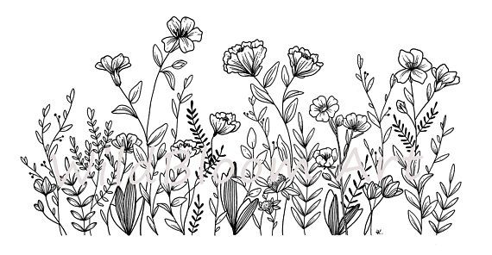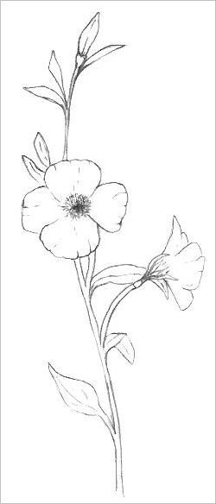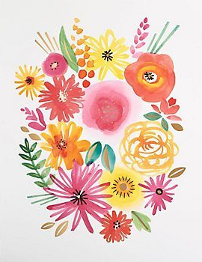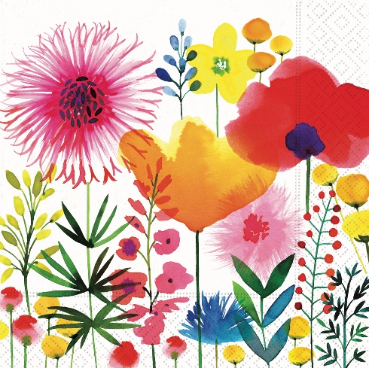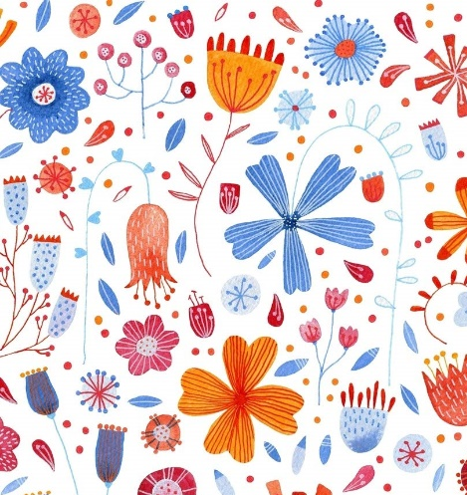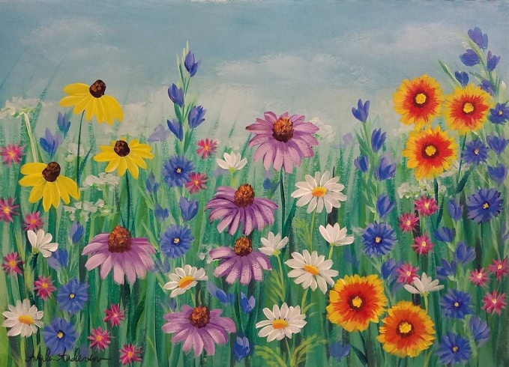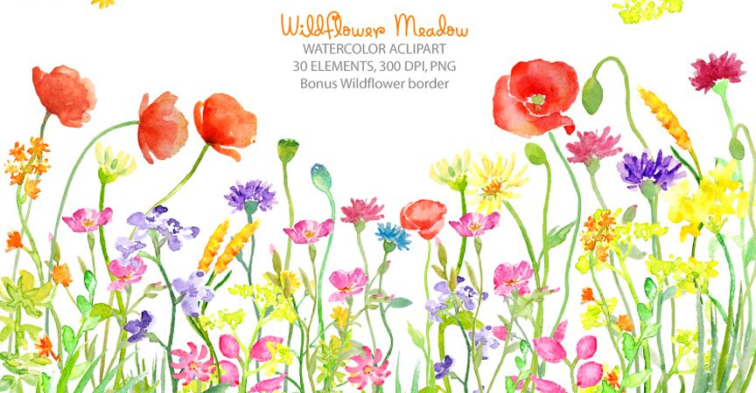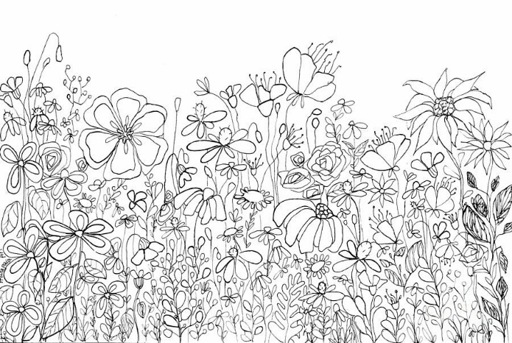
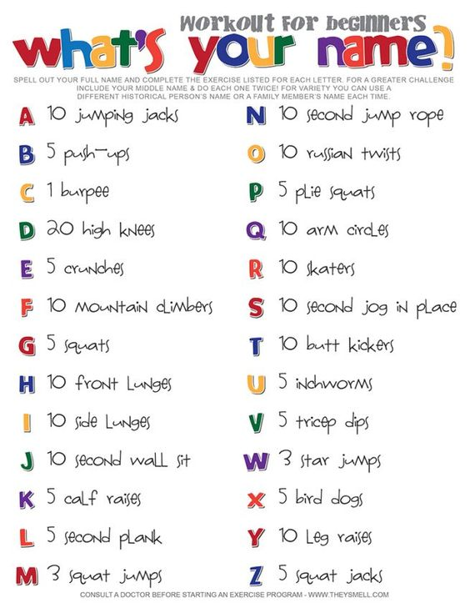
Subject | Monday May 11th | Tuesday May 12th | Wednesday 13th | Thursday 14th | Friday 15th
Maths | Mental Maths Wk 30  Monday  Mathemagic - Weight  5th p. 145 Read / talk through Q1 – 3, do Q4 & 5 in copy, then correct answers.  6th p. 143 Read & talk through Q1 – 3, then on p.144 do Q1 & 6 | , Mental Maths Wk 30 Tuesday  Mathemagic - Weight  5th p. 146 Do all Qs writing the answer only  6th p.144 Q2 & 3, 4 & 5 parts abcjkl | Mental Maths Wk 30 Wednesday  Mathemagic - Weight  5th p. 147 Q1, 2 & 3 a, b & g, then all of Q4, 5 & 6  6th p.145 Q 1 – 4 (all parts)  Then 5 & 6 if you can | Mental Maths Wk 30 Thursday  Mathemagic - Weight  5th p. 148 Q1 – 11, correct and fix corrections  6th p. 146 Q 1 - 8 | Mental Maths Wk 30 Friday Review  Mathemagic - Weight  5th p. 148 Q12 – 20, correct and fix corrections  6th p. 147 Q8 – 19 Follow the pattern to fill in the box or replace the letter
English | Read for at least 20 – 30 minutes  AWW 6 – p. 74 & 75 Read the story of Frankenstein and Dracula. Answer the questions in A & B – you don’t have to write them all down. | Read for at least 20 – 30 minutes  Character Sketch: Create a strange or scary character for your horror story. Make a sketch and include notes about them | Read for at least 20 – 30 minutes  Setting: Decide where you horror story is going to take place. Think about where the characters live and places they go. Then write a paragraph describing one of the places. Include what you can see, smell, hear and feel. | Read for at least 20 – 30 minutes  Roughly plan the main events in your story: gradually introduce the problem, build up to the main point.  Begin drafting the story | Spelling Test  Finish drafting your story.  With a different colour pen, go back and check for capital letters, full stops and speech marks. If you can, see if someone can help you to check spelling, or send me pictures and I’ll help
Irish  An Aimsir – The Weather | Cúla 4 / RTE School Hub / Duo Lingo  Bileog 19 A | Cúla 4 / RTE School Hub / Duo Lingo  Bileog 19 B | Cúla 4 / RTE School Hub / Duo Lingo  Bileog 19 C | Cúla 4 / RTE School Hub / Duo Lingo  Bileog 19 D | Cúla 4 / RTE School Hub Duo Lingo

Monday
Tuesday
Wednesday
Thursday
Week 25 – 5th Class
‘sq’ and ‘pre’

(This must be done Monday to Thursday for homework.)
Look, say, cover, write, check.
1 | square
2 | squirrel
3 | squinting
4 | squeakily
5 | squirm
6 | squealed
7 | squashed
8 | squabble
9 | pressure
10 | pretend
11 | prevent
12 | president
13 | preserve
14 | present
15 | precision
16 | prediction

Monday
Tuesday
Wednesday
Thursday
Week 25 – 6th Class
‘sq’ and ‘pre’

(This must be done Monday to Thursday for homework.)
Look, say, cover, write, check.
1 | square
2 | squirrel
3 | squinting
4 | squeakily
5 | squeamish
6 | squirm
7 | squealed
8 | squashed
9 | squabble
10 | squeakiest
11 | pressure
12 | pretend
13 | prevent
14 | president
15 | preference
16 | preserve
17 | present
18 | precision
19 | prediction
20 | presentation

Obair Bhaile Gaeilge Bileog 19

A.
mo my máthair mother
do your athair father
a his seanmháthair grandmother
a her seanathair grandfather

mo, do and a meaning ‘his’ take a ‘h’ in the next word unless it starts with a vowel.
a meaning ‘her’ does not change the next word, except for words starting with a vowel – these take a ‘h’ at the beginning.

Sampla: my coat = mo chóta your jumper = do gheansaí
his shoes = a bhróga her dress = a gúna her father = a hathair

1. My mother is here. 6. Your car is red.
2. His teacher is listening. 7. Her brother is coming.
3. My grandfather is talking. 8. Her father is sick.
4. His grandmother is in the kitchen. 9. My house is small.
5. Her friend is nice. 10. Your father is tall.

B.

ár our uncail uncle
bhur your (pl) aintín aunt
a their mac son
tuismitheóirí parents iníon daughter

Ár, bhur and a meaning ‘their’ cause the next word to be ‘softened’ if it begins with a consonant. If it begins with a vowel it takes an ‘n’,

Sampla: our box ár mbosca your cat bhur gcat
their child a bpáiste our window ár bhfuinneog
your gate bhur ngeata their dinner a ndinnéar
our house ár dteach our father ár n-athair

1. Our garden. 4. Your friends. 7. Their table.
2. Our boy. 5. Your cousin. 8. Their paper.
3. Our magazine. 6. Your dinner. 9. Their parents. 10. Their uncle.

C.

C.
páistí children cótaí coats
buachaillí boys cailíní girls
múinteoirí teachers siopaí shops
málaí bags hataí hats
peataí pets madraí dogs
prátaí potatoes ispíní sausages

- My pets. 4. Your (pl.) coats and hats. 7. Their dogs.
- His bags. 5. Our children. 8. My boys.
- Her teachers. 6. Your sausages. 9. His girls.
10. Our potatoes.

D.

lámh hand lámha hands
cos leg, foot cosa legs, feet
méar finger méara fingers
súil eye súile eyes
cluas ear cluasa ears
ceann head bolg stomach
ghortaigh mé I hurt tá pian i mo ____ there’s a pain in
d’ardaigh mé I raised my _____
ag cur fola bleeding

1. I raised my hand. 6. He hurt his leg.
2. There’s a pain in my stomach. 7. She closed her eyes.
3. Our feet are cold. 8. My ears are open.
4. He lifted his head. 9. Her finger is bleeding.
5. I cut my fingers. 10. There’s a pain in his eye.

