Suggested Work for 5th & 6th Class Week Beginning May 25th
6th class – please make sure to complete the tasks you need to do for the year book and email them to Sami using the format she requires.
Maths - The topic this week is Data and we’ll start Capacity as well.

English – Most of the work this week is based on Away with Words

Irish – As well as the Bileog included below, do Irish as part of Cúla 4, RTE School Hub or Duo Lingo each day.

Bileog 21 – This sheet revises the verbs and phrases from Bileog 17, 18 & 19 so it might be useful to look back over these if you need help.

There are only 2 short activities from Abair Liom this week. These are writing poems about the weather using a structure provided. The first one on p. 120 is done for you about Sneachta (Snow). In the second one (An ghaoth – The Wind) they give the phrases on the left and you write the poem in the blanks. Then on p. 121 is activities N and O, these are about An Bháisteach – the rain, and An ghrian – the sun. For the last one, come up with the adjectives and phrases first, then use the same structure to write the poem.

Spellings: Spellings for 5th & 6th Class are at the end of this document. Learn and practice these each night as you normally would for homework.

Science – Tin Foil Boat Challenge: Take a break from the book this week to try out this experiment. It’s explained below.

Geography – Counties of Ireland. Learn and revise the counties of Ireland and complete the worksheet and word searches below. The topic for our next zoom Quiz is going to be about the towns of Ireland.

History – Mahatma Gandhi Small World Unit 13 This week everyone will work from the book to read this chapter and learn about Gandhi. When you’ve read the chapter do activity A, B and D Q1. These shouldn’t take too long and you can look back if you need to.

Art: I’ve attached a powerpoint showing a step by step guide for drawing perspective. One you’ve looked through it, use it to draw a street or road using perspective.
Creative Booklet – I’ve included the next task below – you can design your own version of this worksheet, or print and complete the page attached.

PE: Add 2 – 5 minutes to your running fitness challenge from last week. Try to get some fresh air outside, even if the weather isn’t great. Walking, running, scooting and cycling are all good options.

Music: Have fun exploring and learning about the instruments in the Orchestra here. The website is easy to use and has some games too. https://insidetheorchestra.org/orchestra-games/
Subject | Monday May 11th | Tuesday May 12th | Wednesday 13th | Thursday 14th | Friday 15th
Maths | Mental Maths Wk 32  Monday  Mathemagic  5th Data p.157 Q3 (it’s a bit tricky)  6th Data p. 155 Do Q1 – 5, then try Q 6 & 7 if you’ve no corrections. | Mental Maths Wk 32 Tuesday  Mathemagic  5th p. 158 Q 2 & 3, p. 159 Q7, 9 - 12  6th p.156 Q 1 - 6 | Mental Maths Wk 32 Wednesday  Mathemagic  5th p. 160 Q1-3  6th p. 157 Q1 – 5 | Mental Maths Wk 32 Thursday  Mathemagic  Ch. 38 Capacity  5th p. 161 Q 2 - 9  6th (Data) p.158 Q1 i a, Q2 all parts & Q3 | Mental Maths Wk 32 Friday Review  Mathemagic  5th p. 162 Q1 – 3, p. 163 Q1  try some activities on p. 163  6th p.159 Q2&3, p.160 Q1 - 3
English | Read for at least 20 – 30 minutes  AWW Punctuation activity on p80 | Read for at least 20 – 30 minutes  AWW p.81 Pronouns | Read for at least 20 – 30 minutes  Read ‘Shadow’ Poem below and do the activities beneath it. | Read for at least 20 – 30 minutes  p.82 Correcting the mistakes  A – 15 spelling mistakes to correct (I think!?)  B has even more – send me a pic when you’ve done it | Spelling Test  AWW p. 82 Activity C Grammar & Punctuation
Irish | Cúla 4 / RTE School Hub / Duo Lingo  Bileog 21 A | Cúla 4 / RTE School Hub / Duo Lingo  Bileog 21 B  Abair Liom p120 explained above | Cúla 4 / RTE School Hub / Duo Lingo  Bileog 21 C | Cúla 4 / RTE School Hub / Duo Lingo  Bileog 21 D  Abair Liom p.121 explained above | Cúla 4 / RTE School Hub Duo Lingo  Correct and fix Bileog using answer sheet emailed

Tin foil Boat – INSTRUCTIONS

Construct a boat with tinfoil. Here’s a picture, but you can use any shape you like. When you’ve made it, check the boat floats.
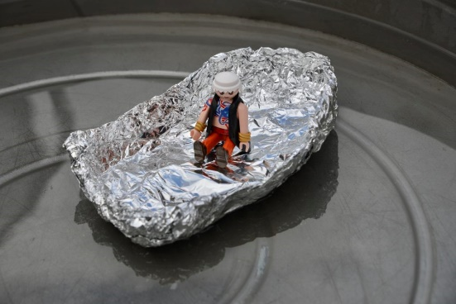
Once you’re happy the boat floats add coins slowly to find out how many coins it takes to make it sink.
Try spreading the coins out for the first attempt and then try again but place all the coins at one end.
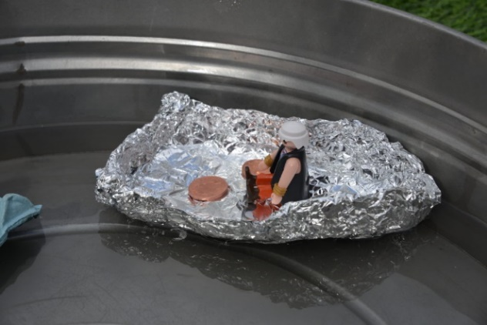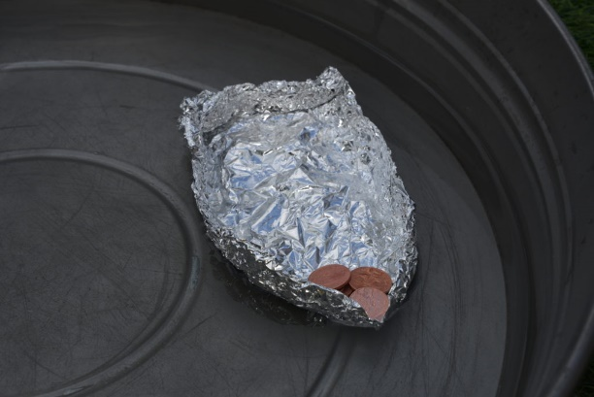
Remember to make sure the coins are dried for each boat you test.

When you’ve done that, you could try this:
Repeat the investigation, but this time use different sized foil boats. Do smaller boats sink with less coins?
Make boats from recycled materials and work out how much weight it takes to make each one sink.
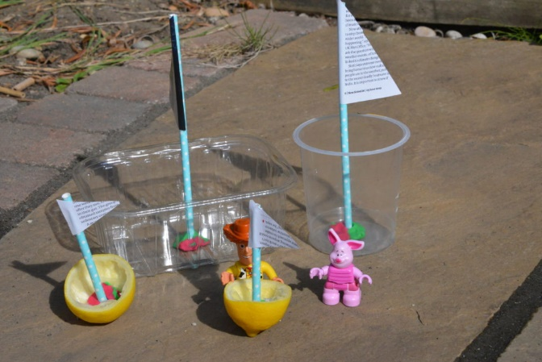

Monday
Tuesday
Wednesday
Thursday
Week 27 – 5th class
‘rr’ and ‘pro’

Remember: ‘o in pro’ is a ‘short o sound’

(This must be done Monday to Thursday for homework.)
Look, say, cover, write, check.
1 | arrive
2 | arrival
3 | tomorrow
4 | interrupt
5 | arrest
6 | hurricane
7 | incorrect
8 | arrange
9 | proper
10 | province
11 | property
12 | profitable
13 | promise
14 | product
15 | probably
16 | problem

Monday
Tuesday
Wednesday
Thursday
Week 27 – 6th Class
‘rr’ and ‘pro’

Remember: ‘o in pro’ is a ‘short o sound’

(This must be done Monday to Thursday for homework.)
Look, say, cover, write, check.
1 | arrive
2 | arrival
3 | tomorrow
4 | interrupt
5 | surrounding
6 | arrest
7 | hurricane
8 | incorrect
9 | arrange
10 | arrangement
11 | proper
12 | province
13 | property
14 | profitable
15 | proposition
16 | promise
17 | product
18 | probably
19 | problem
20 | problematic

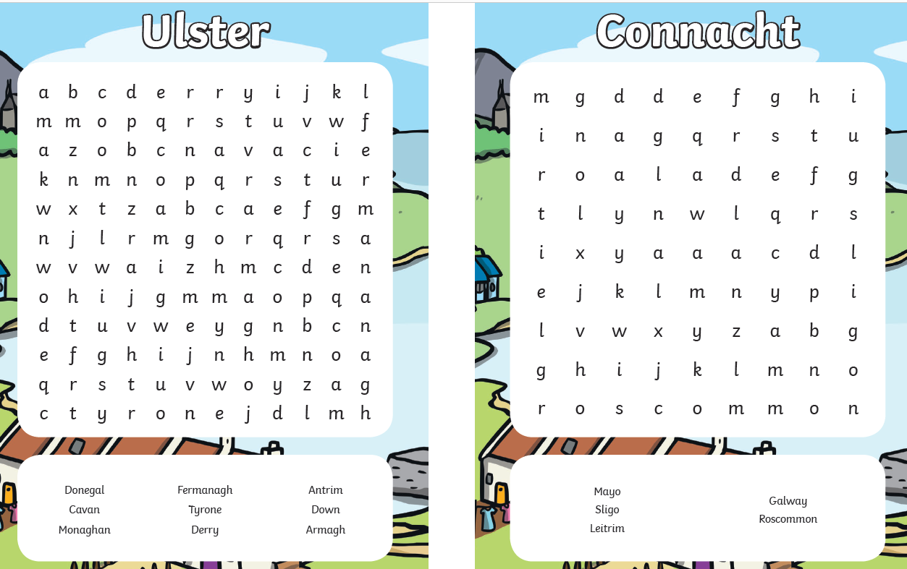
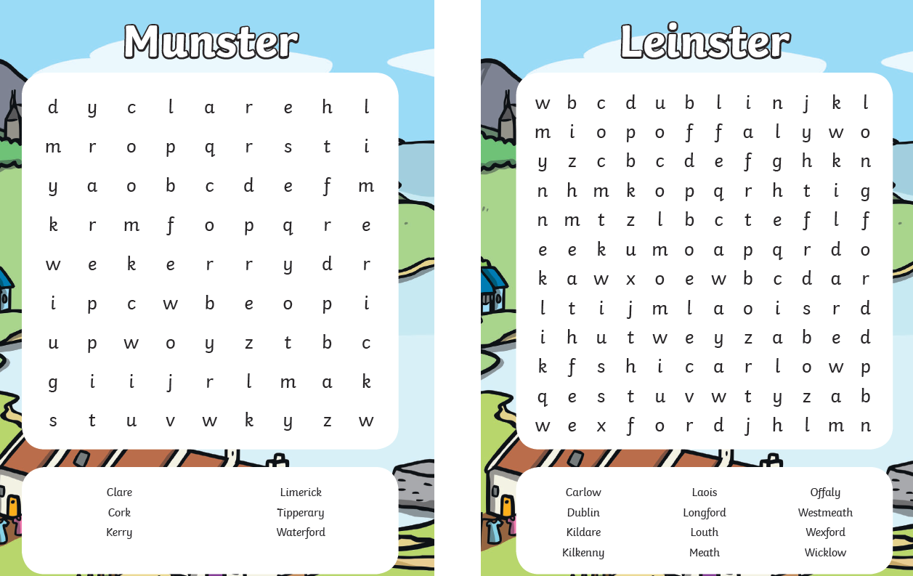

Obair Bhaile Gaeilge Bileog 21
ceannóidh mé I will buy osclóidh mé I will open
maróidh mé I will kill ardóidh mé I will raise
gortóidh mé I will hurt cuardóidh mé I will search
tosóidh mé I will begin / start críochnóidh mé I will finish
dúiseoidh mé I will wake up éireoidh mé I will get up
baileoidh mé I will collect deiseoidh mé I will fix eitleoidh mé I will fly an luch the mouse
an eitleán the aeroplane an eitleog the kite

1. I will wake up at seven o’clock. 6. You will fix the computer.
2. The cat will kill the mouse. 7. He will get up at eight o’clock.
3. You will hurt your foot. 8. The kite and the aeroplane will fly.
4. They will search their bags. 9. You (pl) will collect the copies.
5. I will open the box in a while. 10. He will raise his hands.
A.

ar a haon a chlog at one o’clock ar a dó a chlog at two o’clock
ar a trí a chlog at three o’clock ar a ceathair a chlog at four o’clock
ar a cúig a chlog at five o’clock ar a sé a chlog at six o’clock
ar a seacht a chlog at seven o’clock ar a hocht a chlog at eight o’clock
ar a naoi a chlog at nine o’clock ar a deich a chlog at ten o’clock
ar a haondeag a chlog ar a dódheag a chlog
at eleven o’clock at twelve o’clock
an ceolchoirm the concert an scannán the film
an clár the programme an cluiche the match
an ceacht the lesson cathain? when?

Sampla: Cathain a thosóidh an scannán? = When will the film begin?
Tosóidh sé ar a seacht a chlog = It will start at seven o’clock.

- The programme will start at 6. When will the match start?
9 o’clock. 7. It will start at 7 o’clock.
2. The lesson will finish at 3 o’clock. 8. The film will start at 10 o’clock.
3. When will the concert start? 9. It will finish at 12 o’clock.
4. It will start at 1 o’clock. 10. The lesson will begin at 5
5. It will finish at 4 o’clock. o’clock.
B.

C.
cúig tar éis five past cúig chun five to
deich tar éis ten past deich chun ten to
ceathrú tar éis a quarter past ceathrú chun a quarter to
fiche tar éis twenty past fiche chun twenty to
fiche cúig tar éis twenty-five past fiche-cúig chun twenty-five to
leathuair tar éis half past

Sampla: Tá sé ceathrú chun a haondeag = it’s a quarter to eleven.
Beidh mé ansin ar a leathuair tar éis a trí = I’ll be there at half past three.

1. It’s five past three. 6. It’s a quarter past eleven.
2. I will get up at twenty past seven. 7. I will walk home at a quarter to one.
3. The film will begin at five to eight. 8. The match will finish at half past 4.
4. He returned at ten past two. 9. I started writing at twenty-five to 9.
5. The aeroplane will fly at ten to 5. 10. She will be here at twenty to six.

Sampla: An gceannóidh tú an ríomhaire? = Will you buy the computer?
Ní cheannóidh mé = I will not (buy)

- Will he get up at seven o’clock? He will not.
- Will she start working next Monday? She will not.
- Will they buy a new car? They will not.
- Will he fix the bicycle? He will not.
- Will you open the door? I will not.
- Will I finish my picture now? You will not.
- Will they search the house? They will not.
- Will she collect the copies? She will not.
- Will you raise your hand? I will not.
- Will he hurt his finger? He will not.

D.

