Suggested work for 8th – 12th June 2020: 4th class
 |  | Tuesday | Wednesday | Thursday | Friday
English Reading: | My Read at Home Book 4/5 Read 1-2 stories daily. Answer questions orally/writing. https://my.cjfallon.ie/preview/student/4130/11
Spellings Week 31  Learn & write.  Handwriting | climate chocolate  celebrate trade parade  Next 4-6 lines.  Well-known opposites (worksheet attached) | bandage luggage  ashamed separate disgrace  Next 4-6 lines.  Suffixes: N.T. p.92 | amaze arrange exchange  paste mistake  Next 4-6 lines.  Revision: N.T. p.92 | brigade scale phrase  swept swift  Next 4-6 lines.  Worm words (worksheet attached) | Test-boxes 1-4.  Next 4-6 lines.  Editing  (worksheet attached)
Mental Maths | Questions 1-20 & problem solving daily. |  |  |  | Complete review.
Daily option | https://www.topmarks.co.uk/maths-games/7-11-years/times-tables Choose different topics within 7-11 year age group (5-10 minutes per day)
Tables  Mathemagic 4 | x2, ÷2  Revision: choose 2-4 sums from each row p.171 | x4, ÷4  Revision: choose 2-4 sums from each row p.172 | x8, ÷8  Revision: choose 2-4 sums from each row p.173 | x3, ÷3  Revision: problems 1-9 p.174.  11-13: optional | x6, ÷6
Gaeilge  Litriú | ag snámh=swimming  ag tumadh=diving | na tonnta=waves  ag lapadáil=splashing | gaineamh=sand  an fharraige=the sea | ag an trá=at the beach  buicéad=bucket | Scrúdú: boscaí 1-4
Continue with www.duolingo.com/course/ga/en/Learn-Irish for 5-10 minutes per day.
Try 4 oral questions daily (worksheet attached)

Other suggestions: Check out the fun activities for you to do this week which are attached at the end of this timetable.
The same activities are available on our school website/Facebook page.
-Keep exercising.
-Plan what you’re going to tell/show the other children at our zoom meeting next week.
-Continue reading your own books or read extra pages from the Read at Home book
-Continue learning to type by logging on to www.typingclub.com

Caitheamh Aimsire (Rang 3 & Rang 4)

- An bhfuil aon chaitheamh aimsire agat? (Do you have any hobbies?)
Tá/Níl caitheamh aimsire agam.(I do/don’t have hobbies.)
Tá a lán caithimh aimsire agam. (I have lots of hobbies.)
Bím ag __________.
ag surfáil | ag tumadh (diving) | ag snámh
ag siúl | ag rith | ag dreapadóireacht (climbing)
ag damhsa | ag féachaint ar an teilifís | ag canadh
ag iascaireacht | ag marcaíocht | ag léamh
ag dornálaíocht (boxing) | ag scátáil | ag imirt cluichí ríomhaire  (playing computer games)
2. An féidir leat damhsa/canadh/dreapadóireacht/surfáil/eitilt/léamh? (Can you _?)
Is féidir liom ____________.
3 Cathain a bhíonn tú ag imirt _________? (When do you play _?)
Bím ag imirt ___________ ar _____________. (I play _ on _.)
ag imirt peile ag imirt iomána ag imirt cispheile (basketball)
ag imirt leadóige (playing tennis) ag imirt fichille ( playing chess) ag imirt sacair
ag imirt camógaíocht ag imirt rugbaí ag imirt haca
An Luan | An Mháirt | An Chéadaoin | An Déardaoin | An Aoine | An Satharn | An Domhnach

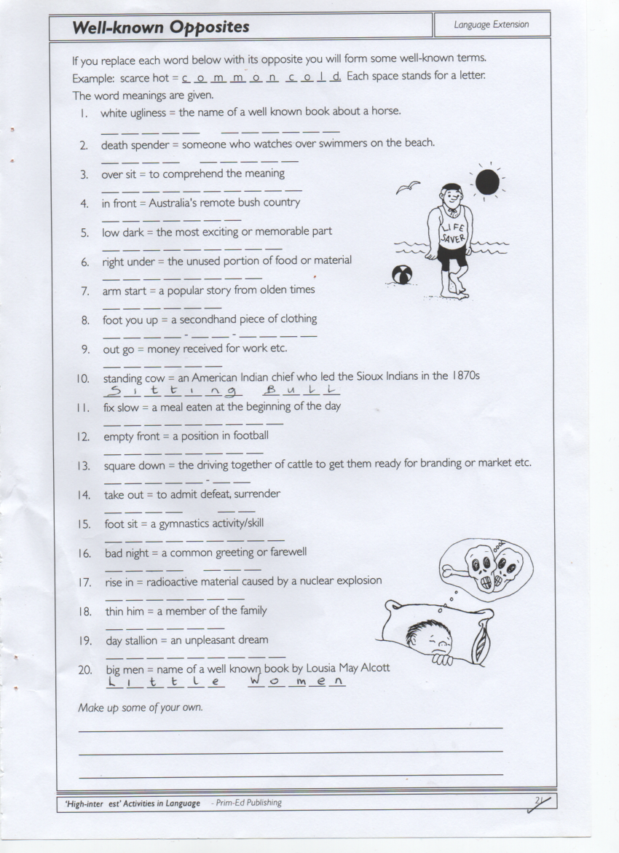

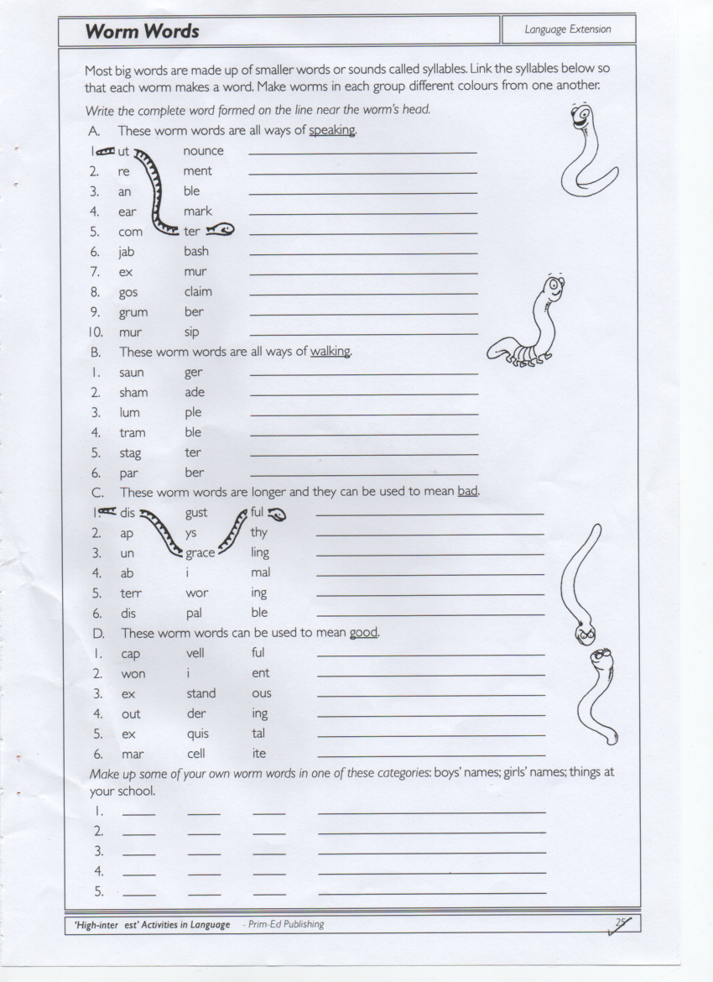

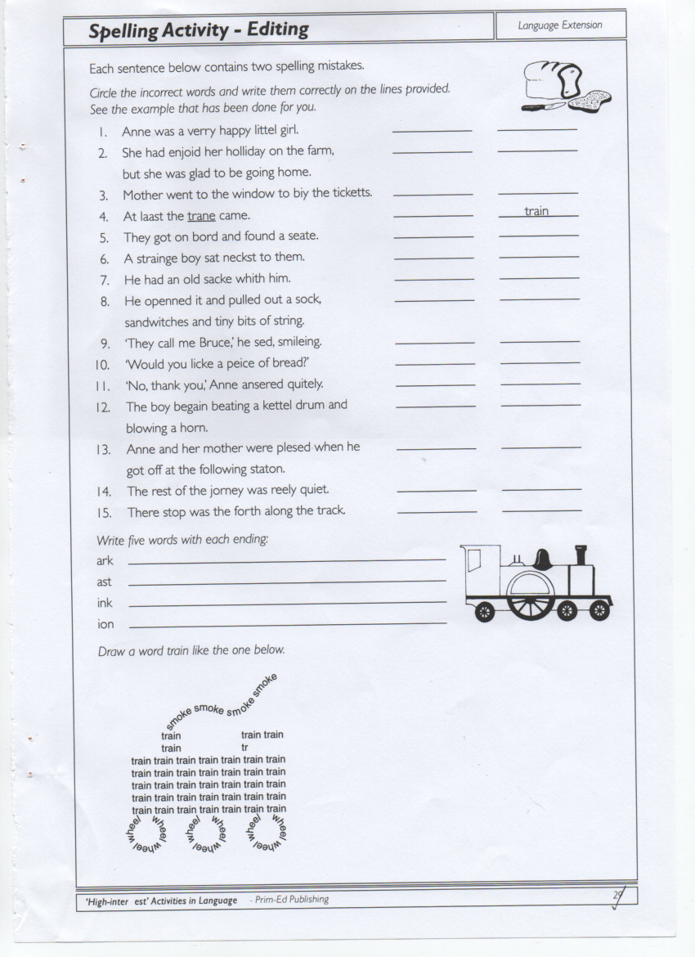

Other Activities for Week Beginning June 8th
Mon. | This is often a good time of year to review Water Safety Awareness. There’s lots of resources and activities for all classes on this website:  https://www.teachpaws.ie/?gclid=CjwKCAjwt-L2BRA_EiwAacX32fmToSOqb8k1kMtmF0FWEWfnF_Vtk0uQVcjIPOrRrZm6gBKKHOl9khoCxPIQAvD_BwE  Following on from the Agri Kids visit in school before we closed, you might like to revisit farm safety for children through the games and activities on http://www.agrikids.ie/gamezone/index.html
Tues. | Have you a whiteboard marker lying around somewhere? Try this activity and see if you can get it to work. Draw figures that become animated http://www.sciencefun.org/kidszone/experiments/dry-erase/  Or if you’re brave enough for something messier, try making your own playdough  http://www.sciencefun.org/kidszone/experiments/home-made-play-dough/ or colourful patterns in milk http://www.sciencefun.org/kidszone/experiments/milk-art/
Wed. | Singing – If you’re missing out on the singing we usually do in school, have a look at this website. https://www.singup.org/singupathome/all-songs  You can download the lyrics and sing lots of well known songs or learn some new songs.  (4-7 year olds) “People who help us” or choose songs from “Silly Stuff” on the playlist.  (7-12 year olds) “One moment, one people” or “In every way” or choose songs that are “Empowering/Inspiring/Sing Up Day Songs” on the playlist.
Thurs. | Eoin O’Connor Art Inspiration  After yesterday’s assembly appreciating our animals why not create an artwork of them? Eoin O’Connor is an Irish artist who specialises in colourful paintings of cows and other animals. Have a look at his paintings and try to create your own version. You can zoom in on the paintings to get a really close look.  https://eoinoconnor.com/collections/animal-original-paintings We’d love to see what you come up with!
Fri. | Wind down with some yoga this Friday. For younger children try Cosmic Yoga Kids for yoga, mindfulness and relaxation for kids. There are interactive adventures which build strength, balance and confidence. https://www.youtube.com/user/CosmicKidsYoga/videos  Older children might enjoy this a bit more: https://www.youtube.com/watch?v=GZFIGiTV6Y0&app=desktop

